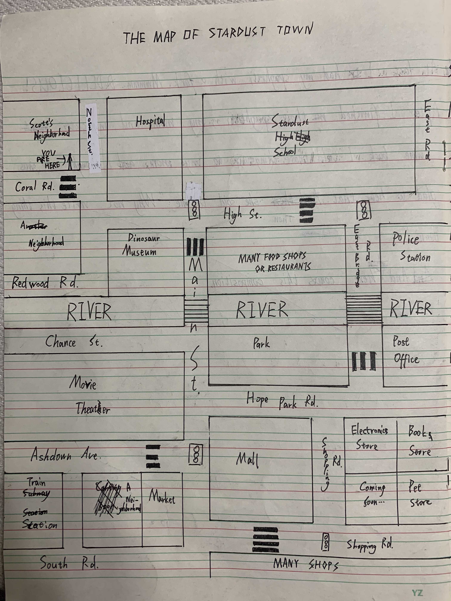

( S:Scott N:Nick)
S: Excuse me, sir?
N: Oh, hi, What can I do for you, boy?
S: Well, I’m new here, my friend called me to go to the movie theater, and I think I must arrive there before her. But I don’t know the way!
N: Calm down,kiddo. It’s not far. You are on the corner of North St.and Coral Rd. Can you understand that?
S: Yes.
N: First, go down North St. Can you see that dinosaur museum?
S: I can. And next?
N: Turn left at the museum. Then go straight to the crossing with a traffic light.
S: I remembered.
N: Good. After you turn right at the crossing, just go straight, until...
S: Until...?
N: Until you get to the second traffic light. Then you can see the theater, which is on your right.
S: Oh! Thank you so much for telling me the way, sir.
N: You are welcome. Have a good time with your friend!
S: Thanks! Bye!

